* War file for machin1





* Jenkins running

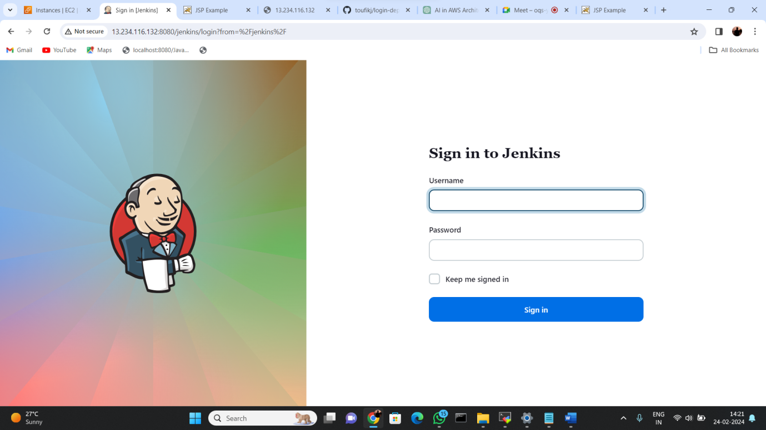

* Push in Repository

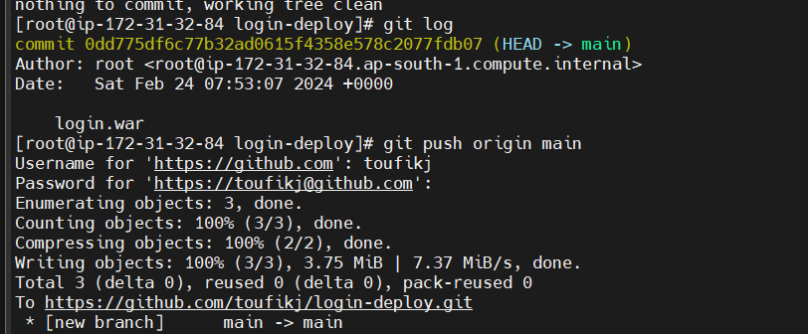

* Cloning repository in another instance

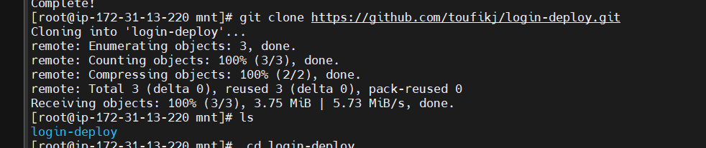

* Coping war file

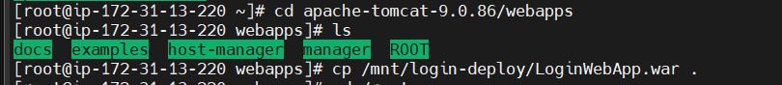

Application running